ANALYSING HOUSING PRICES IN METROPOLITAN AREAS OF INDIA

1. INTRODUCTION

1.1 OVERVIEW:

House price prediction in a metropolitan city in India is a valuable solution for potential home buyers, real estate agents, and investors. By leveraging historical sales data, property details, and location-specific information, a predictive model can accurately estimate house prices. The model's scalability, real-time updates, user-friendly interface, and transparency ensure it meets the needs of stakeholders. Integration capability, data privacy, and cost-effectiveness are also important considerations. By addressing these requirements, the prediction model provides reliable insights, empowering stakeholders to make informed decisions in the fast-paced real estate market.

* 1. PURPOSE:

Problem Understanding, also known as Problem Definition or Problem Identification, is the initial and critical phase of any data analysis or problem-solving process. It involves gaining a clear and comprehensive understanding of the problem at hand, its context, scope, and objectives. T

1. PROBLEM STATEMENT AND DESIGN THINKING:

The objective of analyzing housing prices in metropolitan areas of India is to gain insights into the trends, factors, and patterns that influence the real estate market in these urban centers. By conducting this analysis, we aim to understand the housing prices and identify potential drivers for price fluctuations.

2.1 EMPATHY MAP:

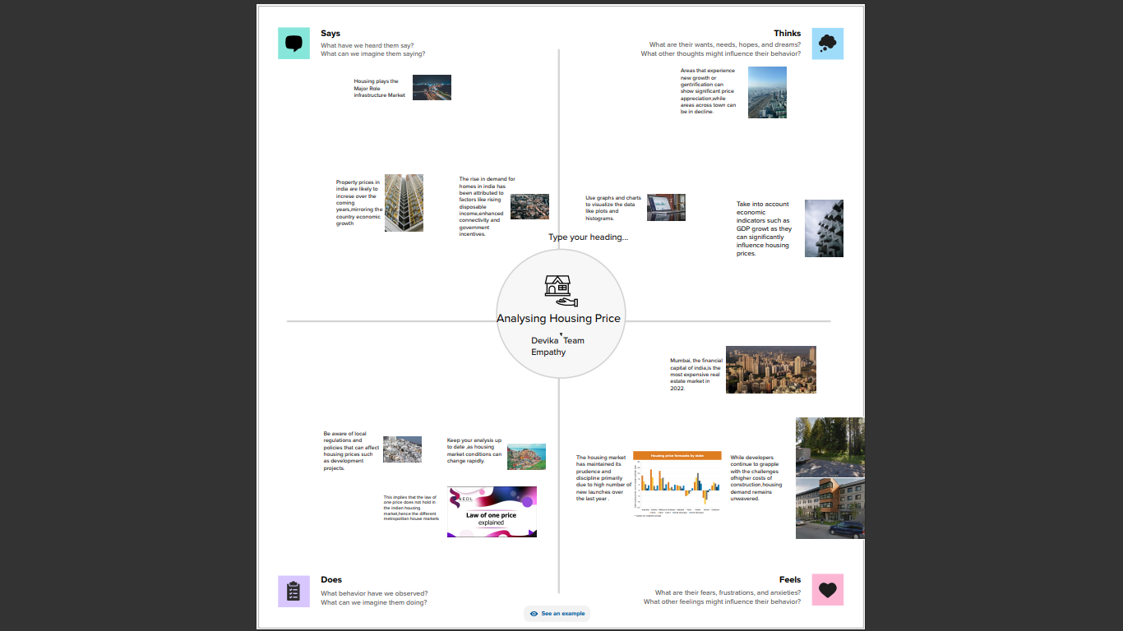

2.1 IDEA& BRAINSTORMING MAP:

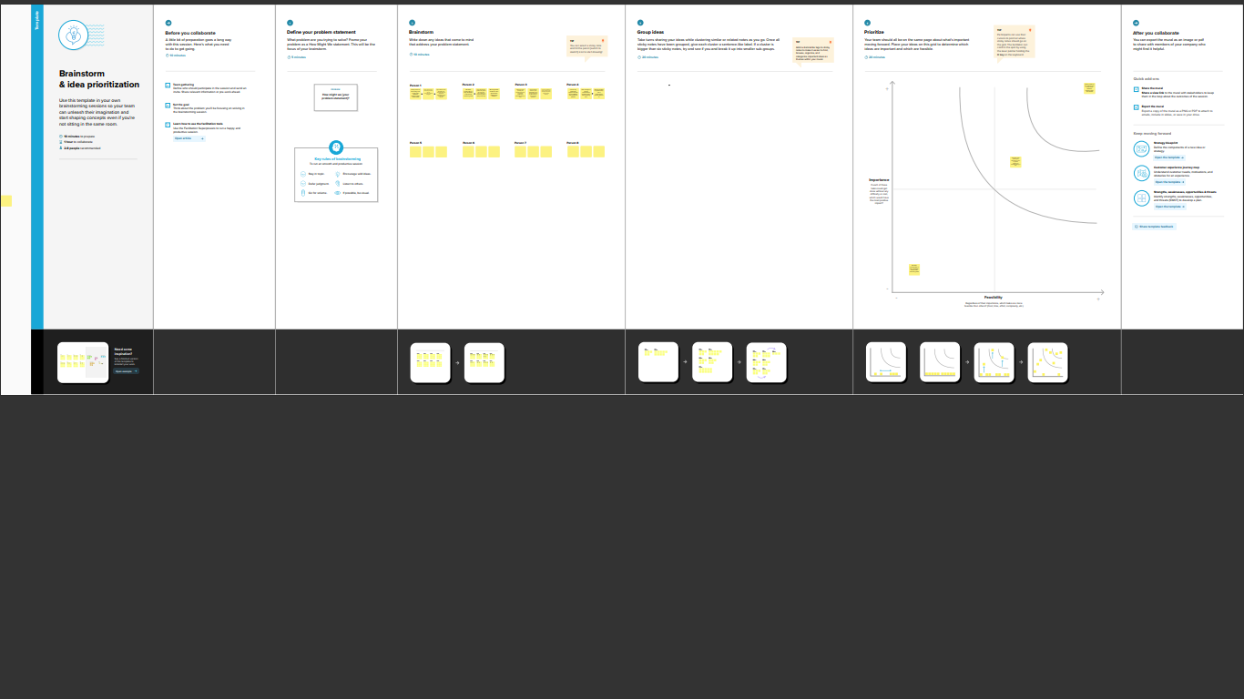

Property prices in India are expected to increase 7.5% on a pan-India basis this year, the fastest growth in five years, according to a Reuters poll of property analysts. Average house prices were forecast to rise 6% next year and in 2024. The poll of 13 property analysts were held during May11-27.

1. RESULT:

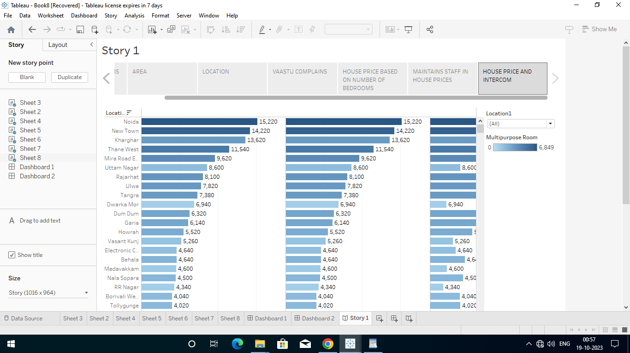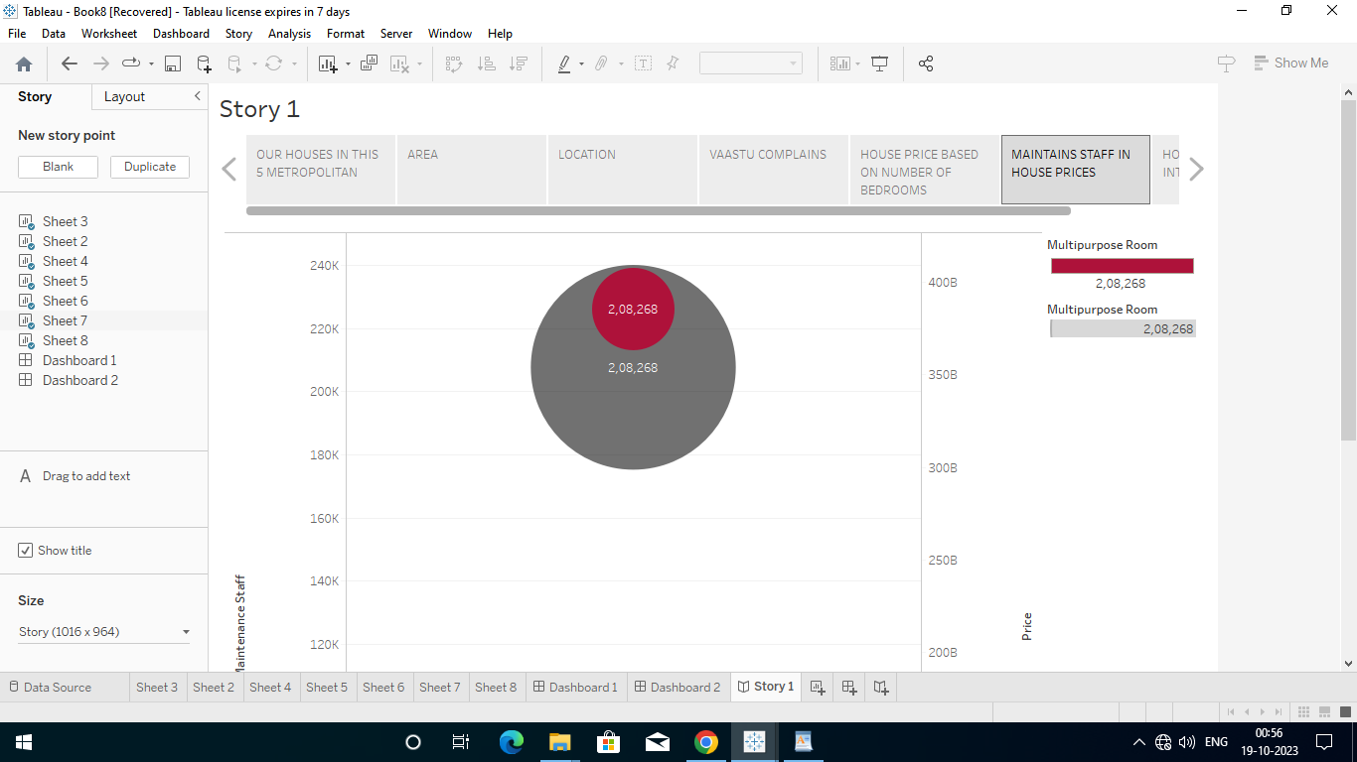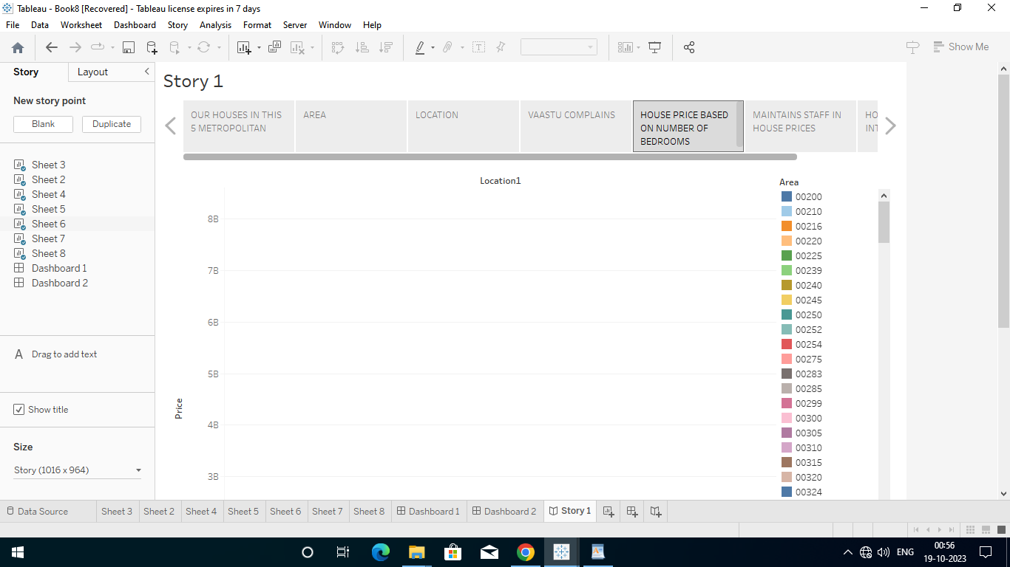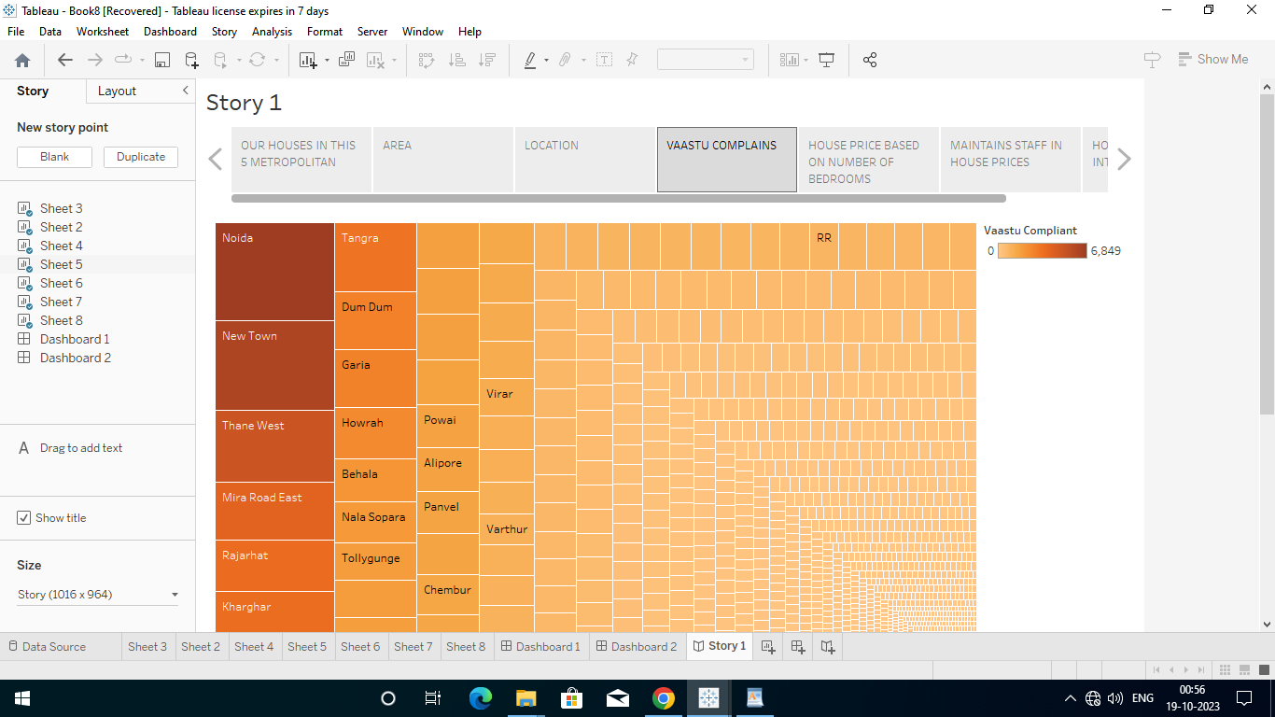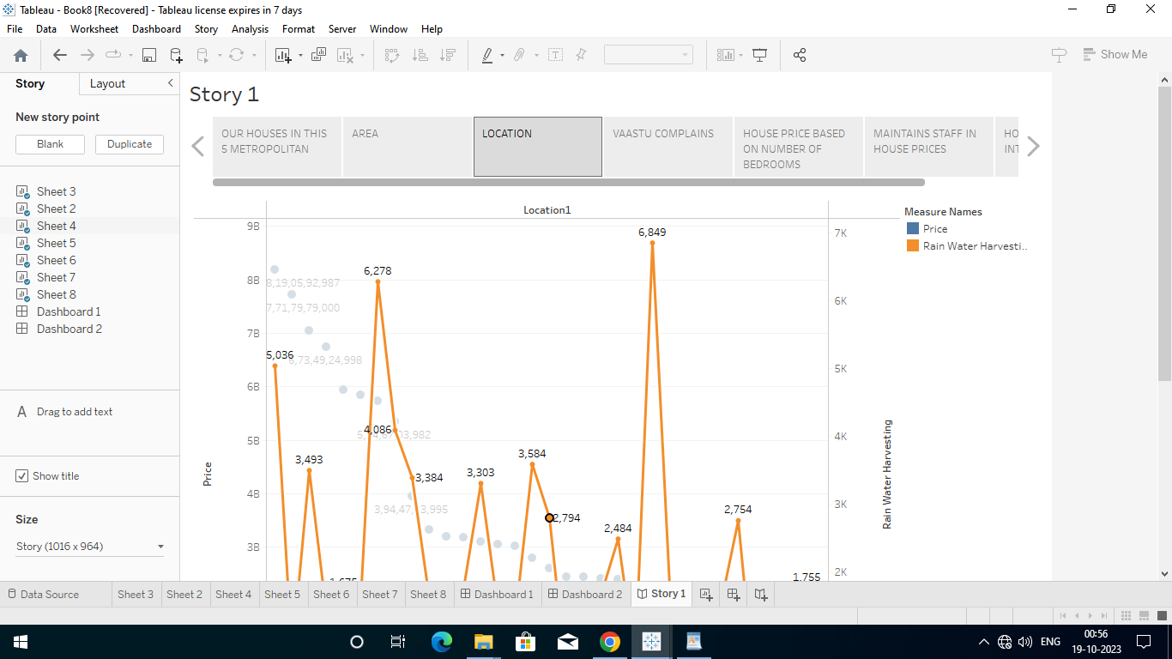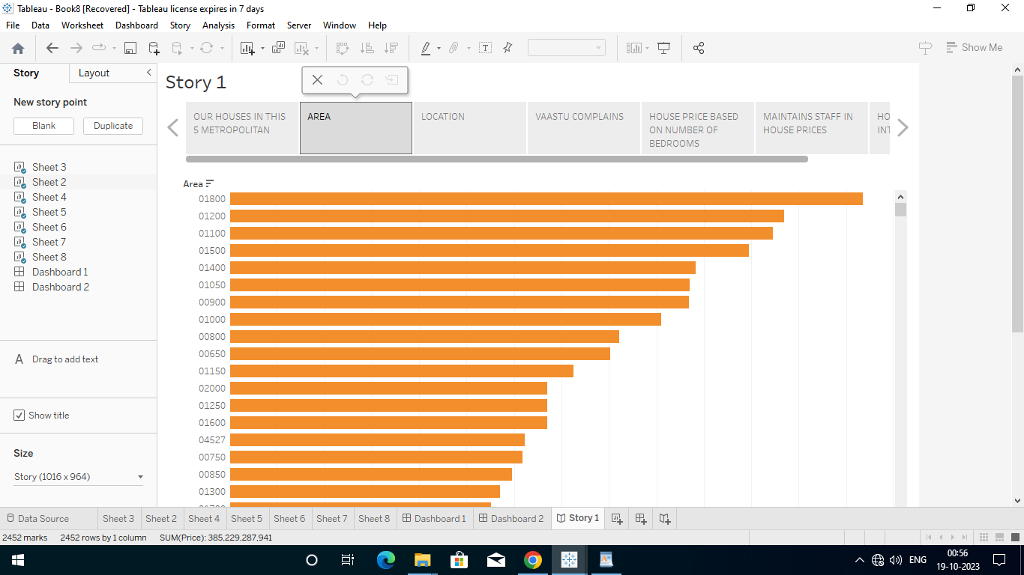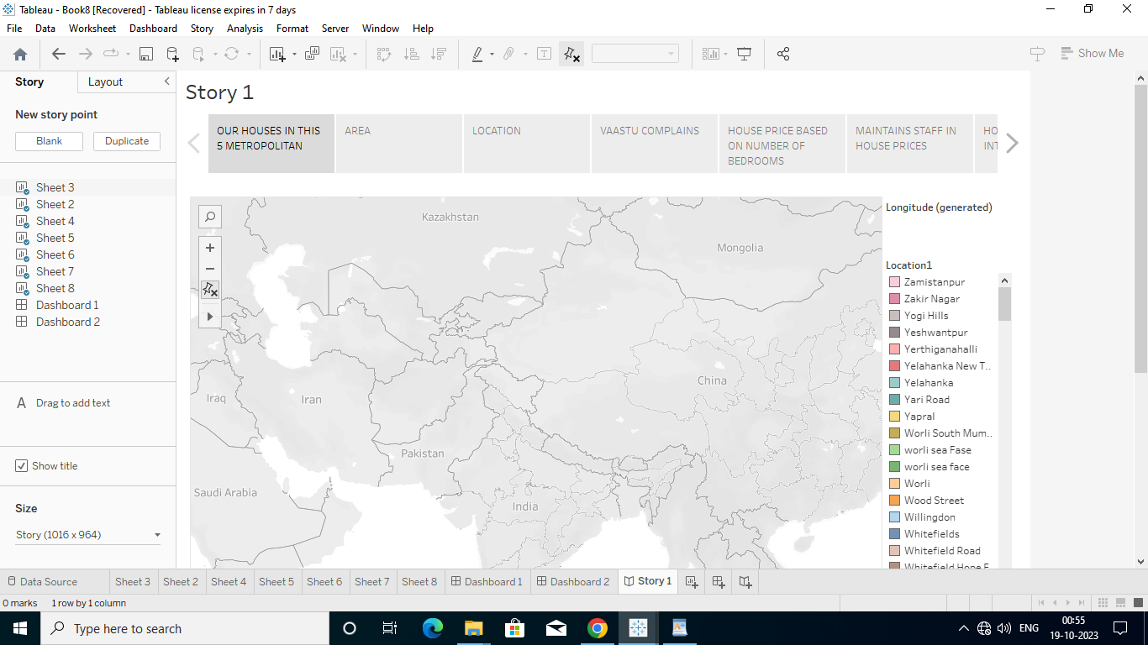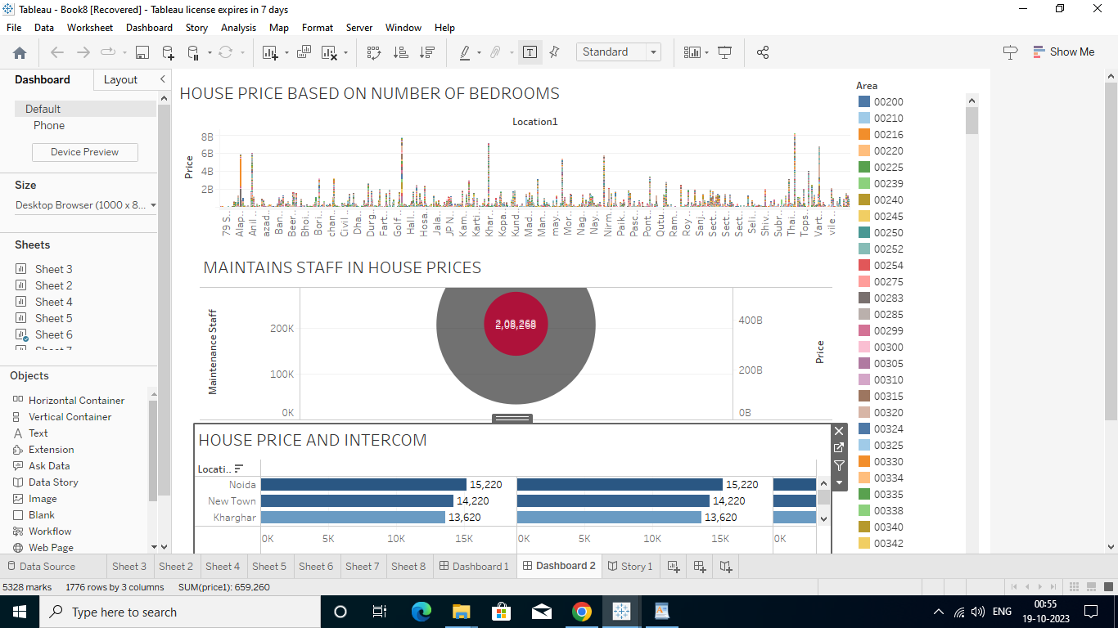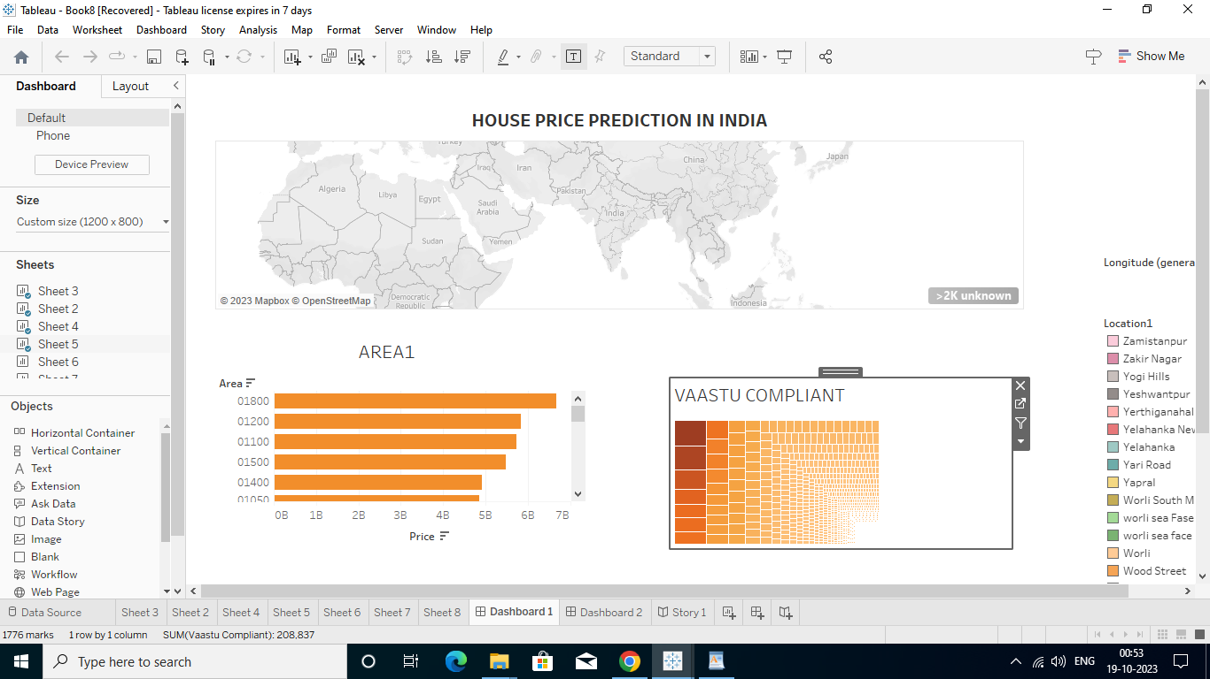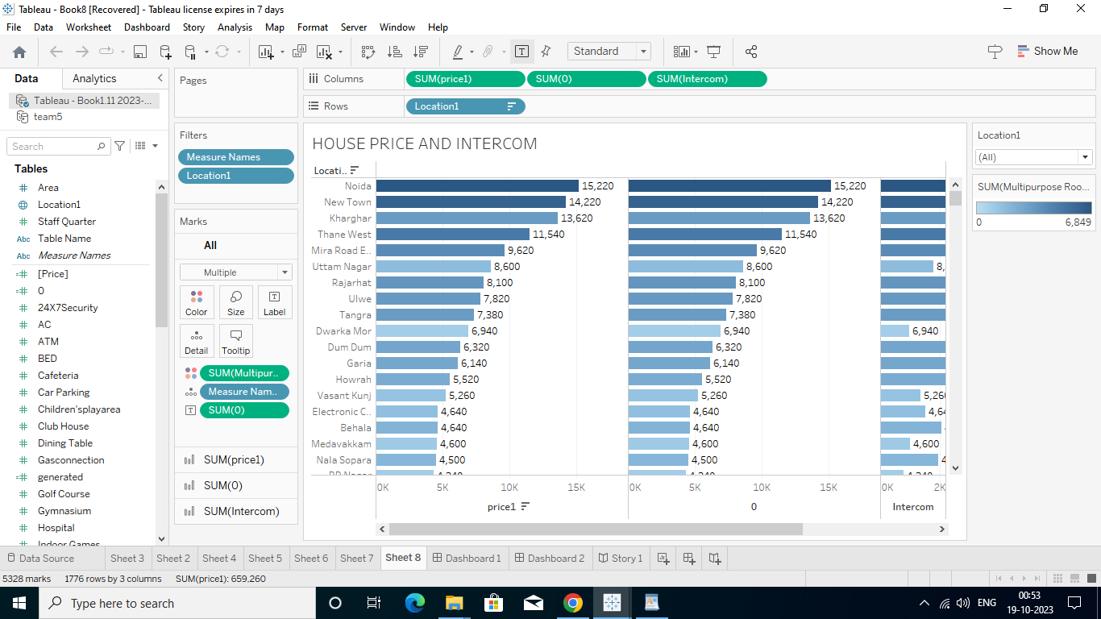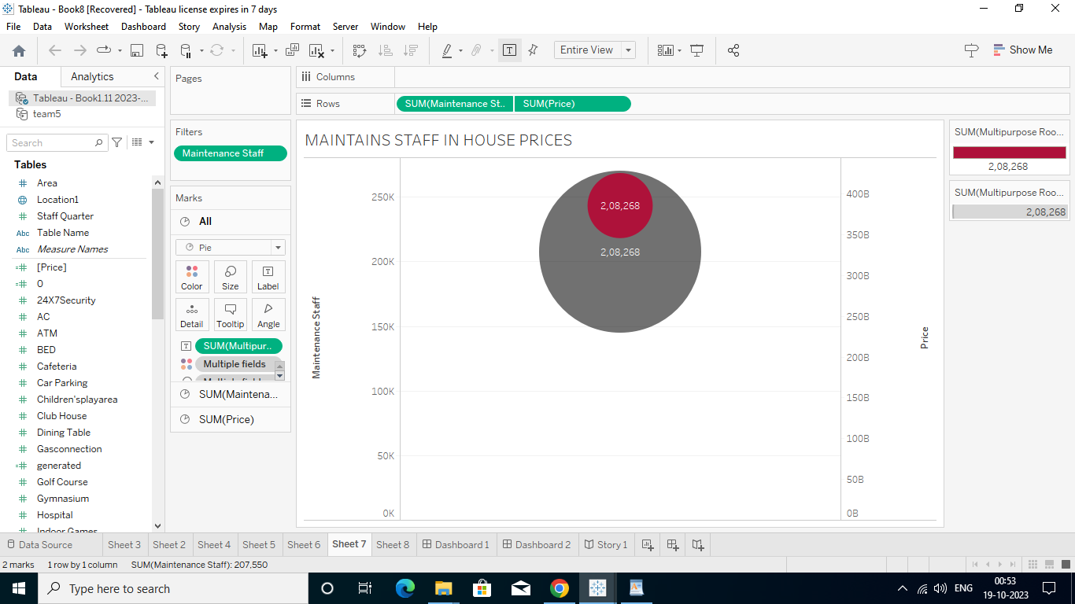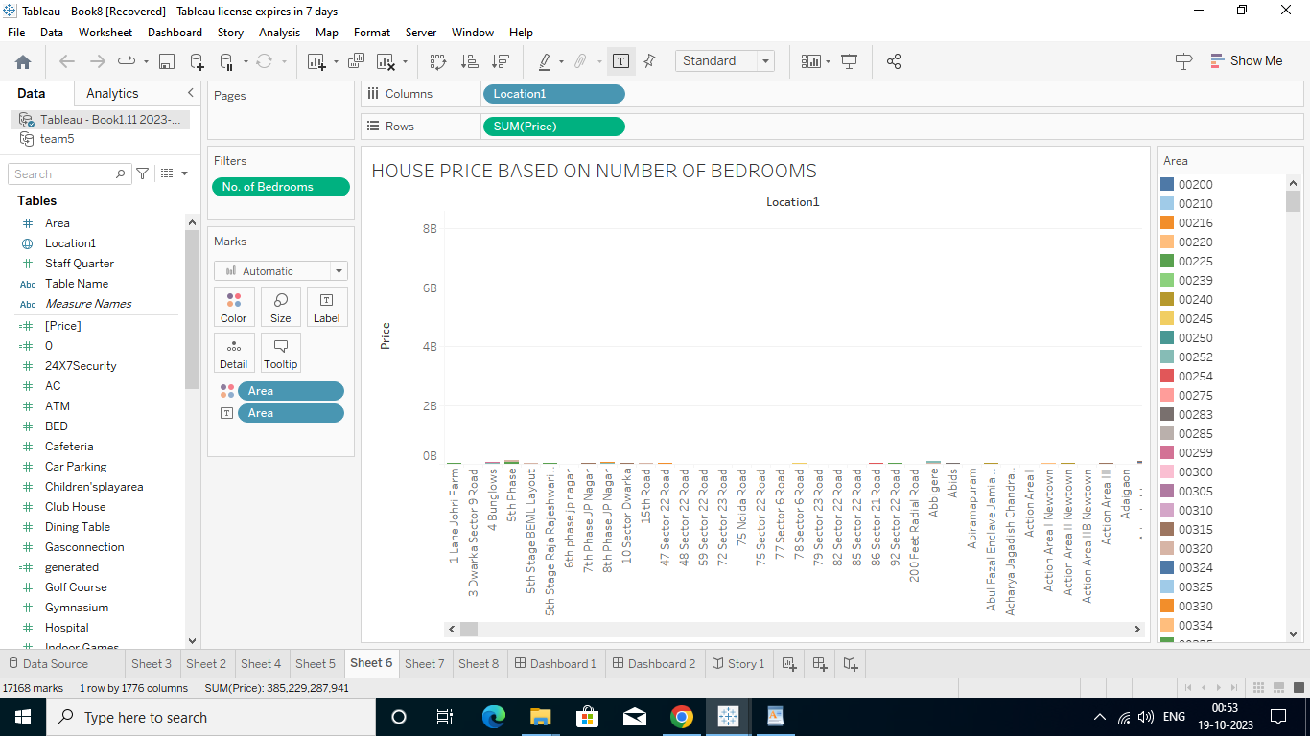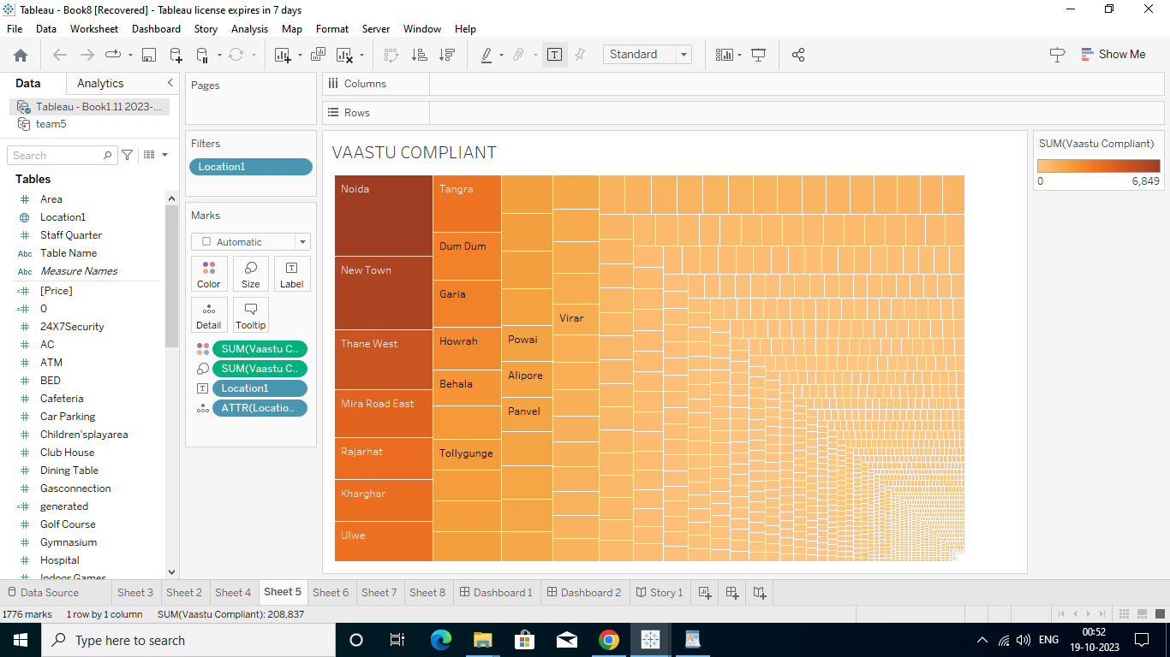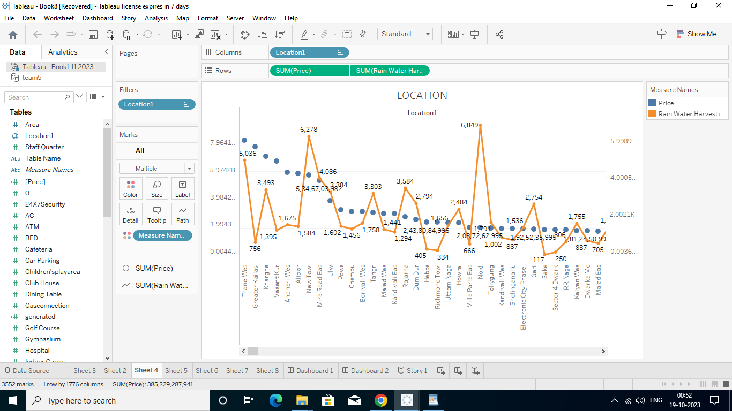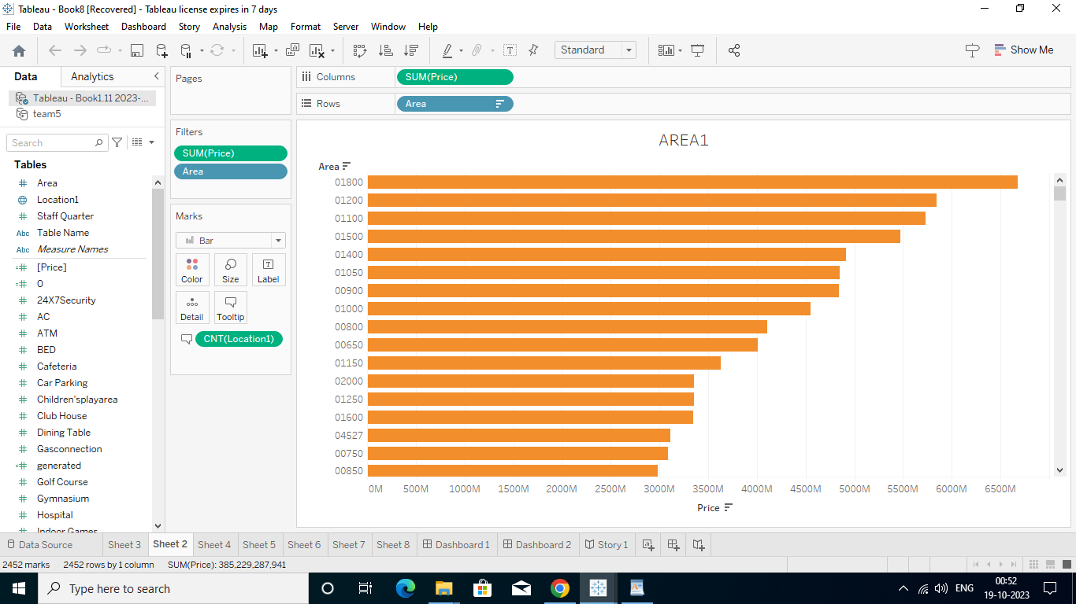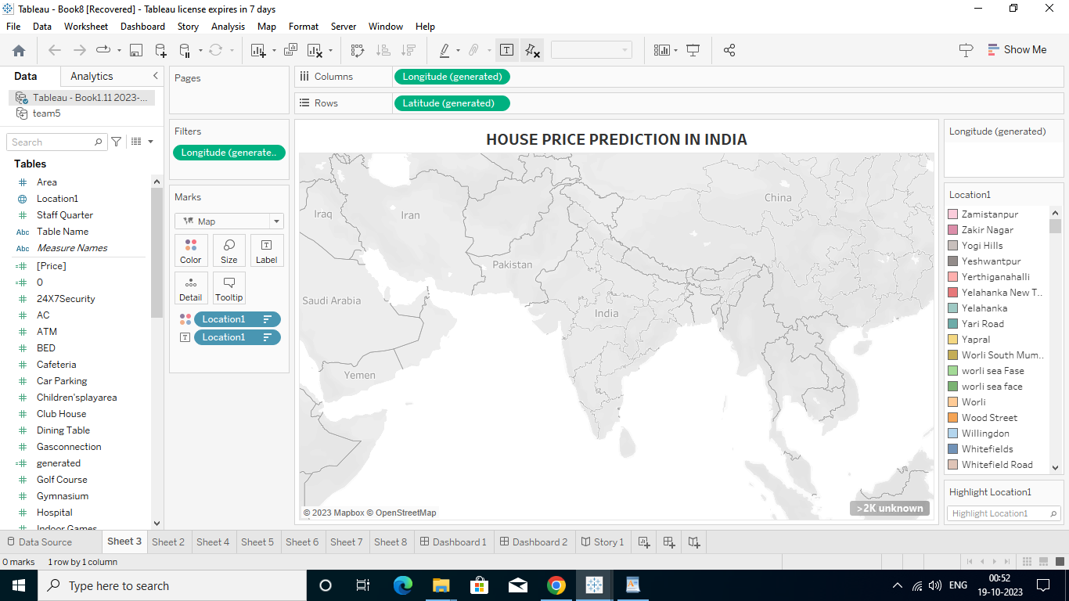

4.ADVANTAGES&DISADVANTAGES:

**Advantages:**

1. **Appreciation Potential:** House prices in metropolitan areas often have a higher potential for long-term appreciation due to population growth, economic development, and urbanization.
2. **Rental Income:** Investing in metropolitan areas can provide a steady stream of rental income, as there is generally a higher demand for rental properties in cities.
3. **Amenities and Infrastructure:** Metropolitan areas offer better amenities, infrastructure, and services, making them attractive to residents and tenants.
4. **Employment Opportunities:** Major cities are economic hubs with diverse employment opportunities, which can lead to higher demand for housing. It is the most important advantage to buy a home in Metropolitan City.
5. **Education and Healthcare**: Access to quality education and healthcare facilities is typically better in metropolitan areas, making them desirable for families.

**Disadvantages:**

1. **High Property Prices:** One of the most significant disadvantages is the high cost of real estate in metropolitan areas. This can be a barrier to entry for many investors and homebuyers.
2. **Competition:** Due to high demand, there can be intense competition for properties, leading to bidding wars and inflated prices.
3. **Traffic and Congestion:** Many metropolitan areas face issues of traffic congestion and limited parking, which can negatively impact the quality of life for residents.
4. **Pollution:** Pollution levels are often higher in cities, affecting air and water quality and overall health.
5. **Limited Green Spaces:** Metropolitan areas may have limited green spaces and recreational areas, making it challenging for residents to find open and natural spaces for relaxation.
6. **Cost of Living:** The cost of living in metropolitan areas can be significantly higher than in smaller towns or rural areas, impacting housing affordability. Also, the cost of living in Metropolitan City
7. APPLICATION:

House price prediction can help the developer determine the selling price of a house and can help the customer to arrange the right time to purchase a house. There are three factors that influence the price of a house which include physical conditions, concept and location

6.CONCLUSION:

Based on the criterion of price convergence, house prices in the 15 metropolitan cities do not converge to the LOOP. This implies that the housing markets in the different areas operate as segmented independent local markets.

1. FUTURE SCOPE:

In 2021, the size of the Indian property market was USD 200 billion. Projected growth by 2030 for the sector is USD 1 trillion. What is more, by 2025, the real estate sector is expected to contribute 13% of the country's total GDP.

The real estate sector is considered to be the second-highest employment generating sector in India. And by 2025, it is believed that it will contribute 13% of the country's GDP. Real estate careers encompass a wide range of possibilities and are always highly in demand.